E_E 511 Protection of Power Systems II

Course Project

Chufeng Sun

11701606

Instructor: Dr. Lotfifard

May 6, 2021

**Fault location methods for transmission lines**

Final report

**Table of Contents**

Abstract 3

I. INTRODUCTION 4

II. Differential equation algorithm technique 5

III. Traveling Wave based on protection 11

IV. Simulation Results for Differential equation technology 18

V. Simulation Results for Traveling Wave fault location 25

Conclusion 32

REFERENCES 34

# 

# Abstract

In the power system, the relay is a very important part. More efficient relay protection methods are needed in ultra-high voltage systems. This paper explains two different ways of power system protection that could fault location for transmission lines. There are differential equations based on protection and traveling wave based on protection. The differential equation algorithm can calculate the equivalent circuit parameters of the transmission line by the fundamental harmonic components of voltage and current. The algorithm gives the circuit RL model, derived from the differential equation. With the resistance and reactance as unknown variables, the unknown variables can be found from the equation to solve the problem. Moreover, for the traveling wave based on protection, when the transmission system fails, traveling waves are generated at the fault point and propagate bidirectionally along the transmission line. Traveling wave protection can detect the direction to the fault within a few milliseconds.

*Keywords* - differential equation algorithm, traveling wave based on protection, fault location

# I. INTRODUCTION

Modern power systems have become more and more complex and voltage levels have become higher and higher. Therefore, it is very important to find the fault point of the system efficiently. Fault location ensures the safety and stability of the system. Distance protection is very important in power distribution system protection. Some people offer a number of protection algorithms for this, such as Fourier and Traveling Wave Protection [1]. When many high voltage systems fail, we should analyze the system and find out the fault line in time, so as to ensure the stability of the system. However, we need to accurately find the occurrence point of the fault, so we need to use the positioning algorithm to measure the voltage and current [2]. Differential equation algorithm technology provides reliable protection on the transmission line. The differential equation algorithm technique can be used in conjunction with fuses to clear faults in the shortest possible time [3]. The differential equation algorithm is usually used for distance protection relays because it provides the simplest and quickest solution. On the basis of this algorithm, it is very important to obtain the data of inductance and parallel capacitance. On the basis of obtaining these data, the voltage and current are highly sampled to perform the relevant calculations. The fault analysis method uses the voltage and current under fault conditions to generate equations to find the distance between the fault point and the ranging point. By taking the fault distance, fault resistance and equivalent impedance of the relative system as unknown variables, a nonlinear differential equation can be obtained simply from the simultaneous differential equation of a fault network and a fault component network. By solving the nonlinear equation, they found the fault distance.

The traveling wave method is commonly used. With the application of digital signal processing (DSP) technology, various digital processing algorithms can be used to detect and accurately locate transmission line faults [4][5]. The traveling wave method is the most accurate and widely used fault location method in a power system fault location [6] [7]. The accuracy of the algorithm mainly depends on the extraction of fault time. How to extract the fault wavefront time effectively is one of the most important problems in the study of power system traveling wave behavior. The single-ended traveling wave method is mainly used to analyze the characteristics of traveling wave components, so as to realize the identification of traveling wave properties.

# II. Differential equation algorithm technique

In Fig. 1, the three-phase transmission element can be represented by resistance, capacitance, and inductance. In this method, the model of the transmission line is either lumped series impedance or a single PI segment containing the line parameters to the fault. The current and voltage at the relay points are related by a differential equation. To some extent, the algorithm includes the high frequency oscillations that may occur when the fault occurs. This is represented by including the effect of the transmission line capacitance, using a single PI cross section of the transmission line.

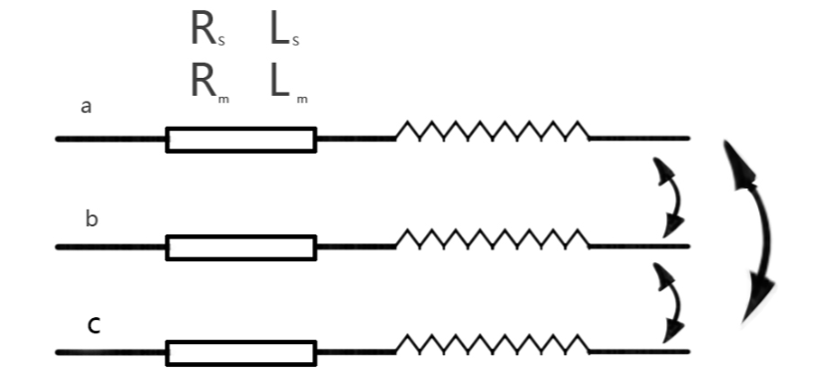

Fig 1. Transmission line

The Differential Equation Technique provides an accurate and fast solution for protecting transmission lines. In the actual three-phase circuit, we make the following assumptions: 1.The line is short in the sense that it does not need to be modeled by surge impedance and wave propagation; 2.The voltage and current transformer are ideal in The frequency range of The algorithm, 50 -- 300 Hz; 3.Load current is neglected; 4.The fault resistance is small; 5.The line is perfectly transposed; 6.Shunt capacitance is neglected [3]. According to the Fig 1. below, Rs and Ls represent resistance and inductance of Km phase, and Lm represent mutual inductance. We can get:

Where:

dx represents the distance of the fault point.

After conversion, we can get:

If the line is ideally transposed, we can get

So, we can get

If there is a single phase to ground fault, according to the above equation, we can get

In Equation (5), where:

X represents the location of the fault,

Va is the voltage of phase a,

diy=ia+(Lab/La)*ib+(Lac/La)*ic.

Since the error minimization of the approximate solutions of the integral and differential equations can also be included in this procedure. If the influence of parallel capacity is required to be considered in the modeling circuit, the error of line parameter estimation will increase. Using this technique, the serial R and L parameters of the circuit can be sensitively estimated. In equation (5), we know the values of V and I. In addition, the solutions obtained by the differential equation and the integral equation are approximately equal, so we can integrate Equation (5) to get [8]:

Where, iy=ia-ib

In this way integrals in harmonics can be filtered out of the waveform within the selected limits. As shown in the figure below:

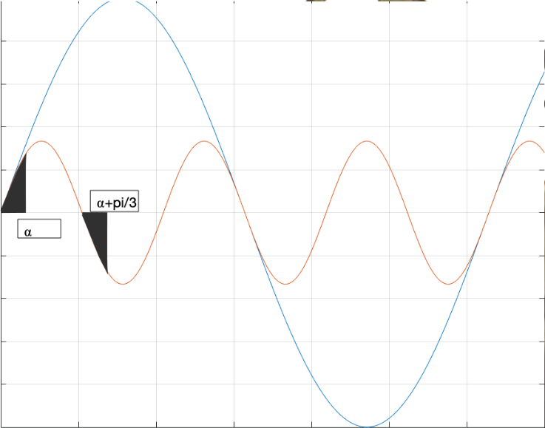

Fig 2. physical interpretation of digital filtering by integration over selected limits

Where t0=0, t1=⍺/w0, t2=(π/3)/w0 and t4=(π/3+⍺)/w0. As can be seen from the figure, the areas of the two third harmonics are just opposite and thus can cancel each other out. Therefore, the interference of the third harmonic can be filtered out. The mth harmonic can be eliminated in the same way. On the other hand, since the integral of the whole period of the sinusoidal function is always 0, we can eliminate the influence of the mth harmonics by first integration. Then, it only needs to eliminate the influence of n harmonic waves. We can get the following formula [8]:

From the above formula, R and L can be calculated to eliminate any number of harmonics.

In addition, we can relate the differential equations of current and voltage. This means that we can take at least two or more samples of voltage and current at intervals. In this way, we can write down the related equations for R and L, and get the values for R and L. We call it Simultaneous Differential Equation techniques [8].

Where According to Equation (8), we take two groups of voltage and current samples respectively, and get:

We change Equation (9) into matrix form, and get:

In Equation (10), we need a total of four current samples and three voltage samples, and we call this algorithm the short-window algorithm. In addition, we can expand the sample size, we can take six current and voltage samples at the same time [7]. So we can get:

Eq. (11) is called the long-window algorithm. From the data point of view, the long-window algorithm has more samples than the short-window algorithm, and is more accurate than the short-window algorithm. However, it also takes longer to compute [9]. Due to we could get equation:

By the same way, we can get the matrix:

Using the above equation (13), we can find the corresponding value of R or l. Then the calculation is made according to the basic value of transmission line. So as to find fault point.

# III. Traveling Wave based on protection

When a fault occurs on the line, the propagation of the fault points will produce both ends of the traveling wave line, and the transient fault voltage and current waves will propagate from the fault points to both ends of the line. At the same time, refraction and reflection occur at the fault point and at both ends of the line. The traveling wave protection principle is based on the detected failure of the fault wave, due to the early principle of fault traveling wave traveling wave protection, the fault information of traveling wave current or voltage combined together, can be detected in a very short time.

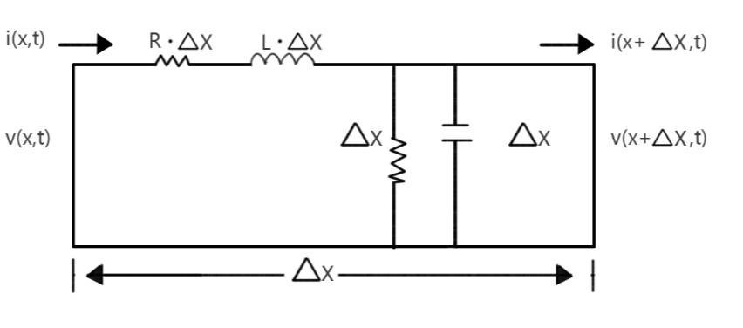

Fig 3. The two-conductor transmission line

According to Figure 3, Kirchhoff's law can be used to obtain:

We make a mathematical change to equation (14). Detailed discussions can be found in [10] and other advanced textbooks on electrical engineering. We can get:

Where:

,

,

,

s(s)=

(s)is called receiving-end voltage reflection coefficient. called the transit of the line. -end voltage reflection coefficient [10]. In the single phase fault, according to Equation (15), we can get the value of the voltage or current within a certain time.

On the other hand, at any point along the voltage wave, except at zero, the fault generates a step wave that propagates in both directions from the fault location. One way to locate the fault is to accurately measure the arrival time of the TW at both ends of the transmission line [11]. This is shown in Figure 4

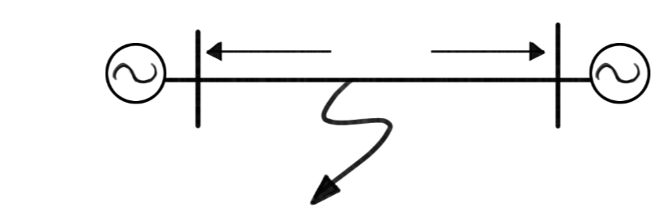

Fig. 4. Traveling waves propagates in both sides from the fault

In practice, we usually use network communication to transfer data from the other end to the origin end. In this way, you can measure the delay signal between the two ends through the detection of the computer. Figure 5 shows the 1955 TW fault location system for BPA's 500kV AC transmission network. The two-ended system uses microwave communication to send a pulse signal TW arrival time from the remote end [12].

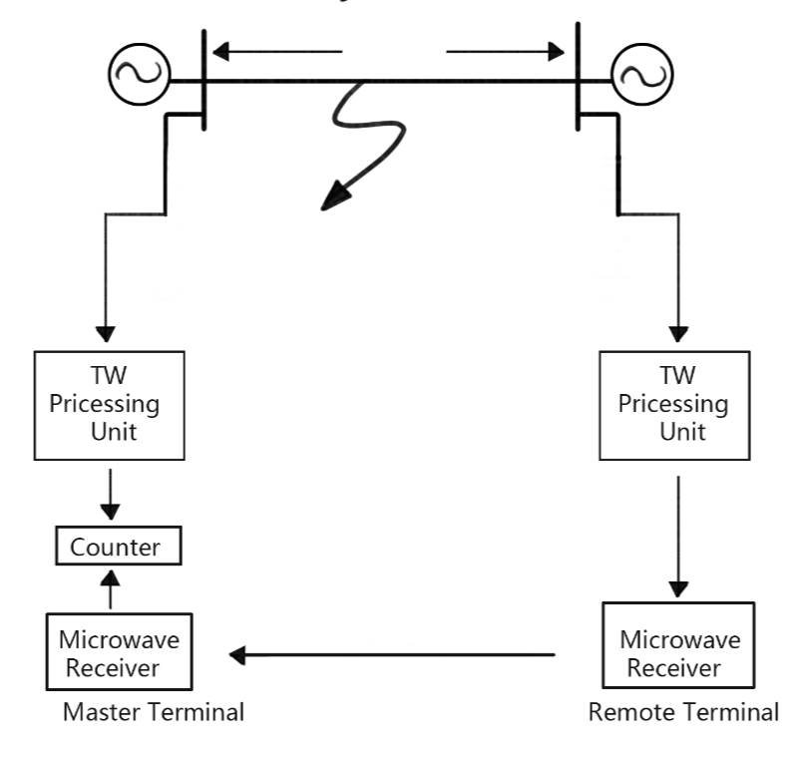

Fig. 5. TW fault locating operation based on time of arrival conveyed via microwave channel [12].

As shown in Figure 5, the terminal sends a pulse signal to the primary port. However, since the communication signal is delayed, a delay compensation is added to the main port. This is the fault location.

However, modern Traveling Wave monitoring systems detect the system in simple time to achieve the function of fault location. The specific model is as follows:

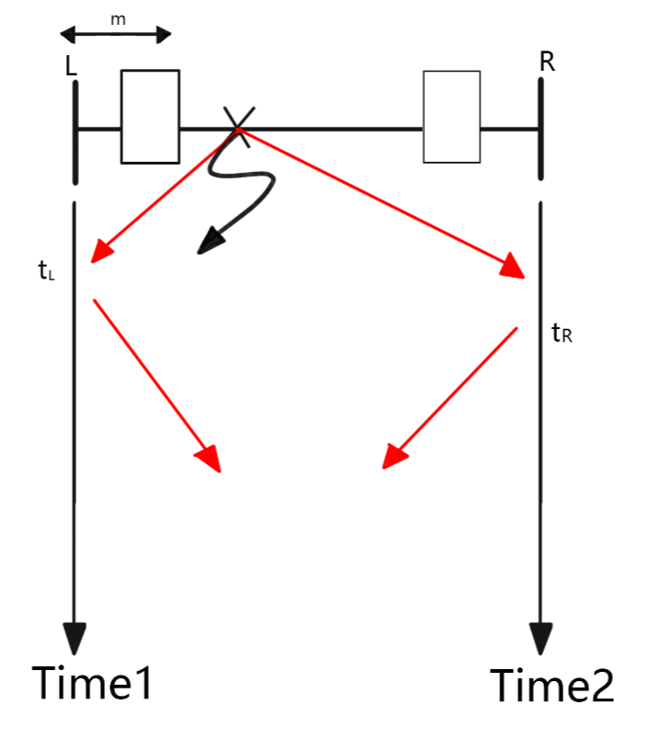

Fig. 6. Fault locating principle

When a grounding fault occurs at the fault point, the fault surge is transmitted to both ends of the line. The processes of refraction and reflection occur at the junctions and terminations. The detector collects the arrival time of each fault traveling wave. As shown in Figure 6, we can calculate the point of failure in a simple time. The specific formula is as follows:

Where:

t1 is the time when the first signal is received.

t2 is the time when the second signal is received.

V is the Traveling Wave propagation velocity ().

The equation(16) is based on a single-ended fault location. If we use a two-terminal fault location, we should use the following equation:

Where,

tL is the Traveling Wave arrival time at L.

tR is the Traveling Wave arrival time at R.

L is the length of the line.

High-frequency transients caused by power system failures travel at speeds close to the speed of light. However, high-voltage transmission lines are optimized to operate at the rated power system frequency, with a standard value of 50 or 60 Hz, and some of these are DC lines. A great deal of engineering work has been done to reduce transmission line losses at these frequencies, without considering TWS performance at high frequencies (0.1 ~ 1 MHz) [12]. In addition, we can use Formula (15) to get the corresponding Bewley lattice diagram. Similarly, formula (16) and (17) can be used to directly obtain the point of the fault. The detailed diagram is as follows:

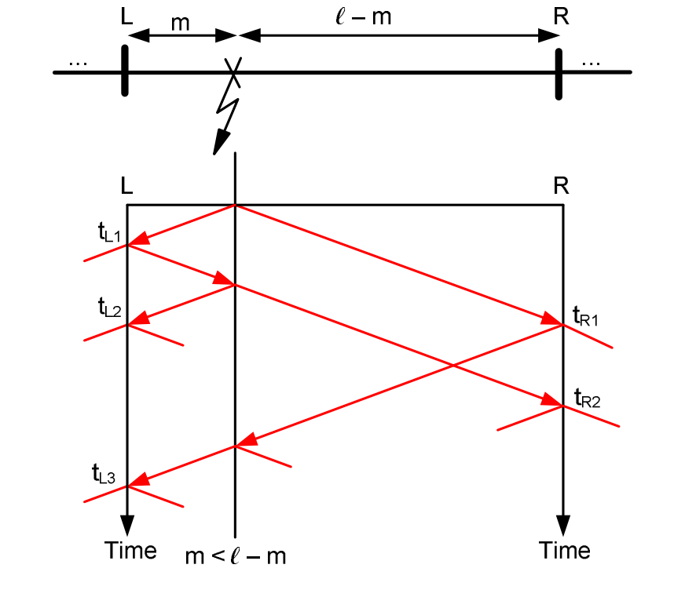

Fig. 7. The Bewley lattice diagram based on transmission line.

Figure 7 shows that when faults occur on the transmission line, traveling waves are sent to both sides from the fault point. If the fault point occurs in the middle of the transmission line, the traveling wave must take the same time to reach both ends. The transient fault voltage and the current waves propagate from the fault point to both ends of the line. At the same time, the process of refraction and reflection occurs at both ends of the fault point and line. When a line is a hybrid transmission line connecting cable and overhead line, the impedance of the cable and overhead line is different, leading to the refraction and reflection of the connection points of the faulty cable and overhead line, further increasing the complexity of the traveling waves reaching both ends of the line.

For the practical model, we use the Clark transform to transform Ia, Ib and Ic to become and I0.

The traveling wave technique is used to locate faults, and the traveling wave propagation speed is required to be uniform. This is done by using modal transformations. In this method, the coupled voltage and the current signals are converted into a new set of modal voltages and currents that can be considered separately as single-phase lines. Similarly, we can perform the same Clark transformation for the voltage.

# IV. Simulation Results for Differential equation technology

The simulation is based on MATLAB /Simulink. The simulation is based on a voltage of 25 kV. We set the length of transmission line as 300km. Then, A-ground, A-B-ground, A-B-C and A-B-C-ground were observed respectively. The parameters of the simulated system are given below.

Transmission line length= 300km

Source parameters:

Phase - phase V =25kv, f= 50 Hz, R=0.8929ohm, L=16.58*

Transmission line:

R0=0.01273, R1=0.3864, L0=0.9337*, L1=4.1264*

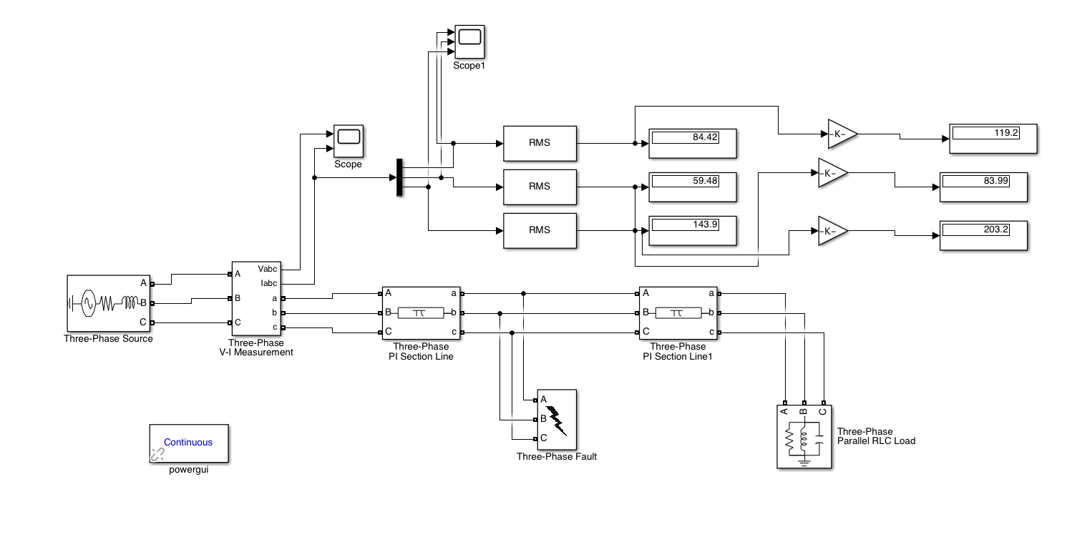

Fig. 8. Three-phase circuit analog diagram

We set the fault to occur in 0.1s , and the fault location is 30km. Then according to Fig 8. We can get images based on each fault type.

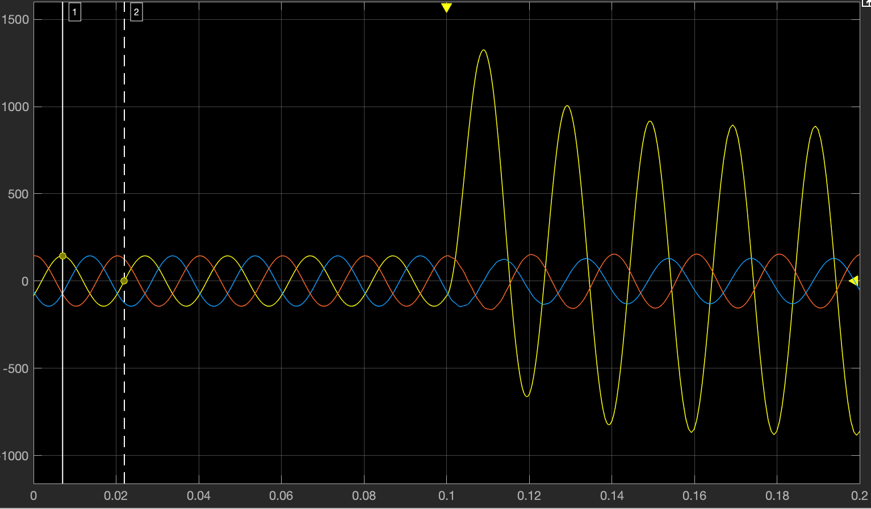

Fig. 9. The Current of A-ground fault

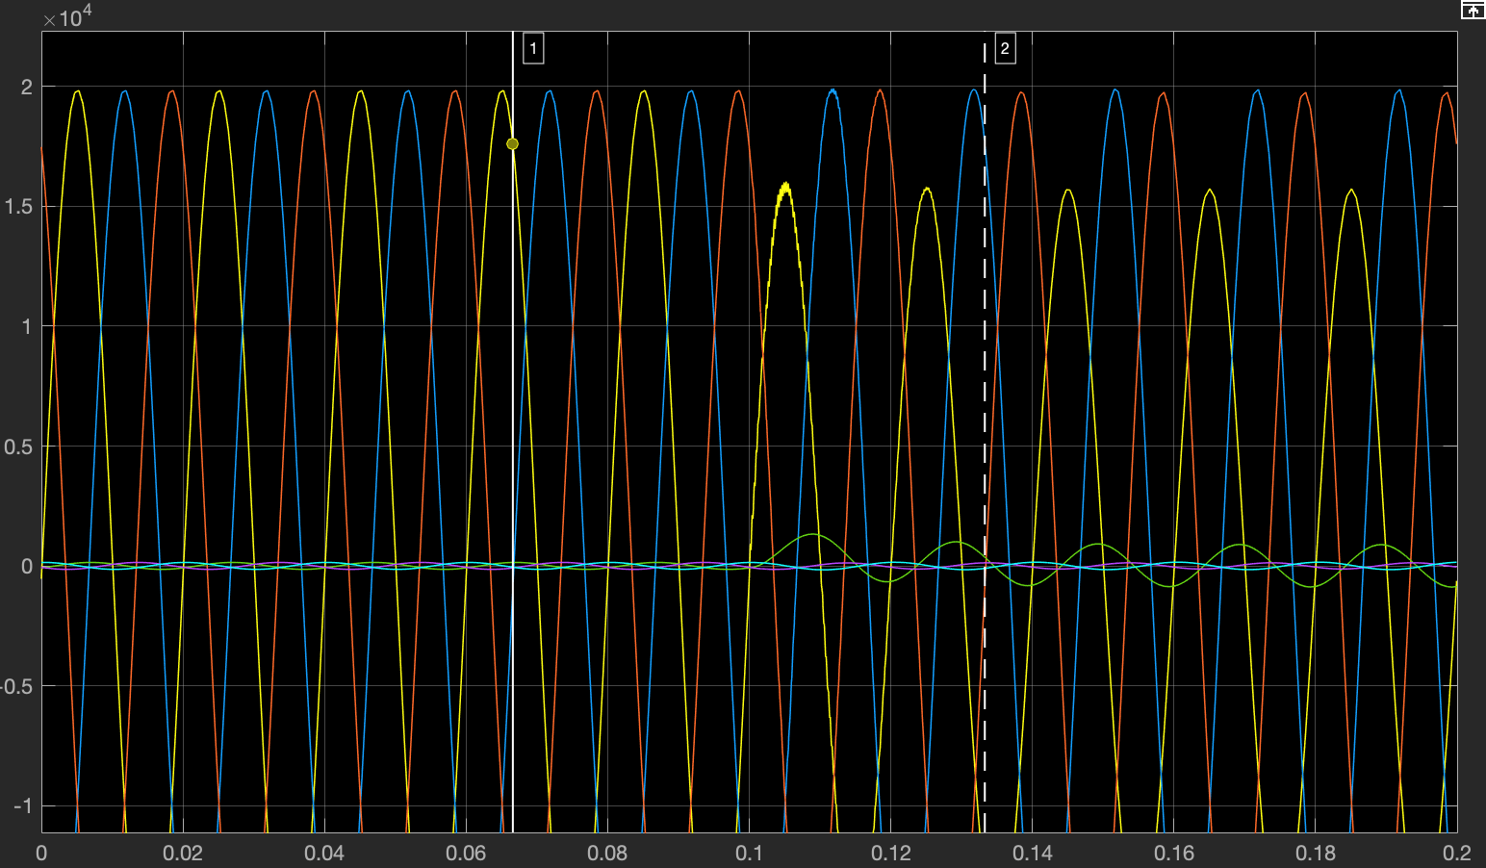

Fig. 10. The Voltage of A-ground fault

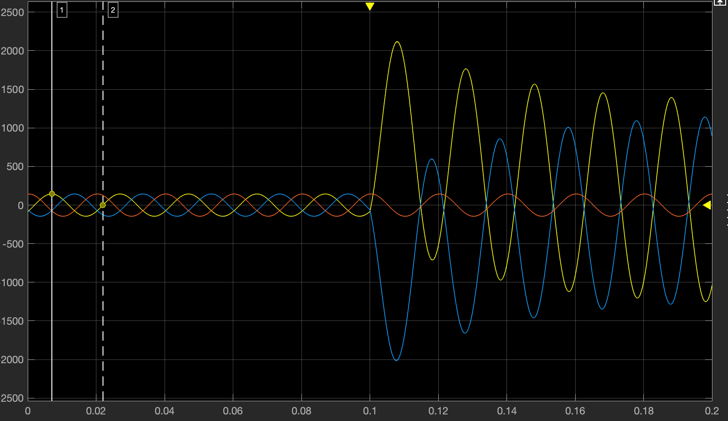

Fig. 11. The Current of A-B fault

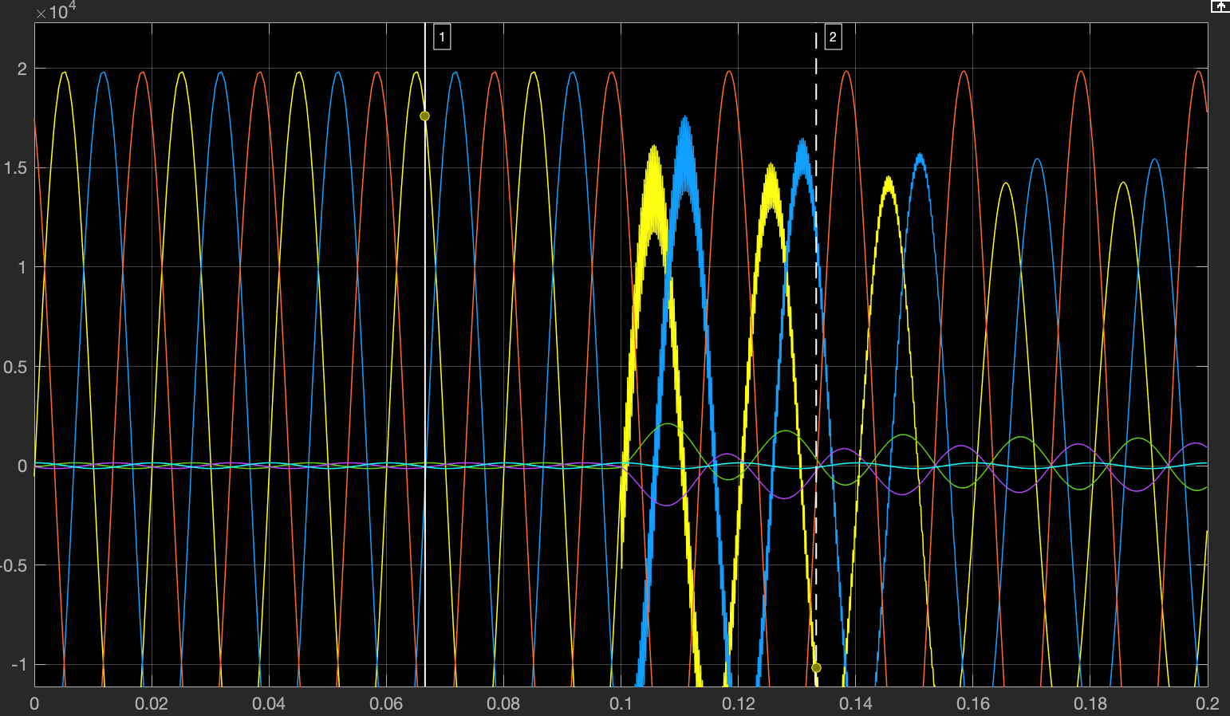

Fig. 12. The Voltage of A-B Fault

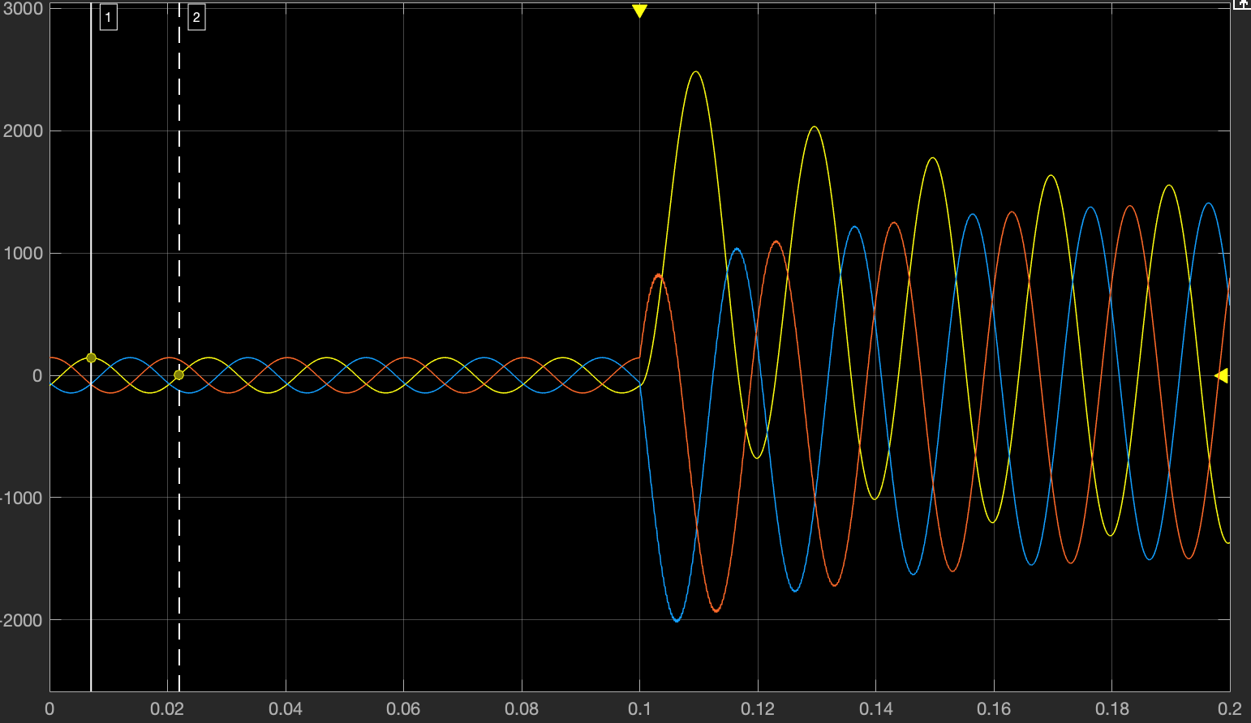

Fig. 13. The Current of A-B-C Fault

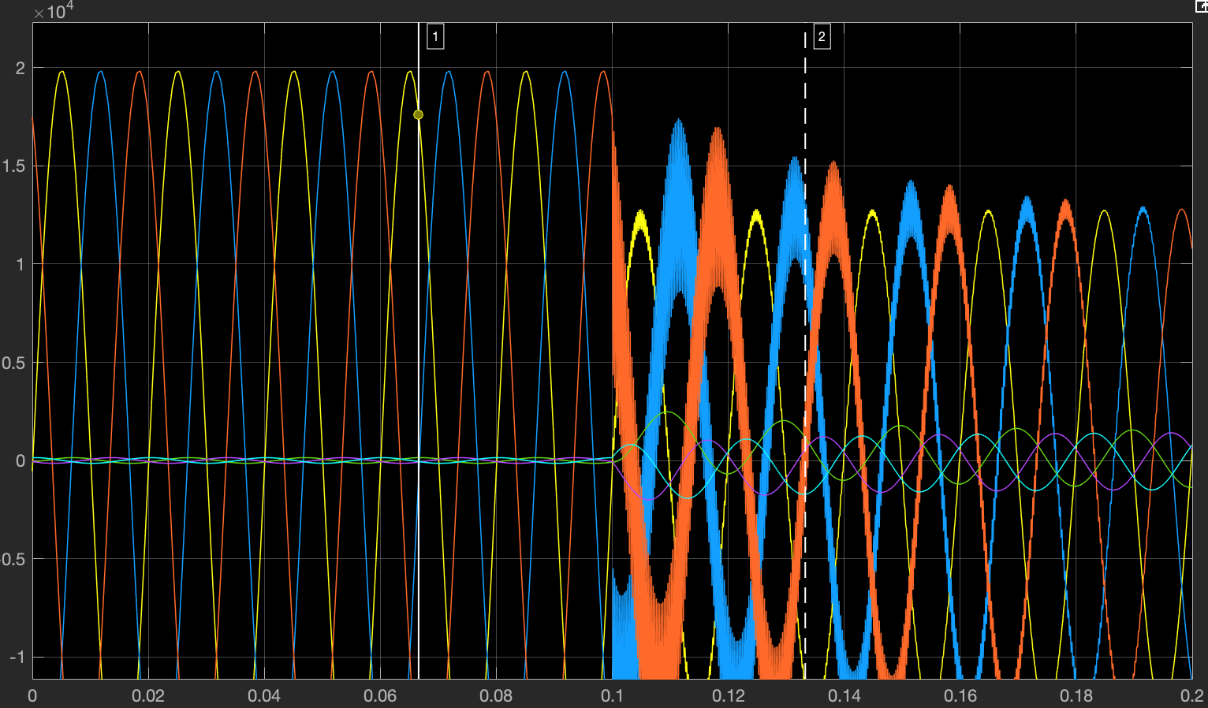

Fig. 14. The voltage of A-B-C Fault

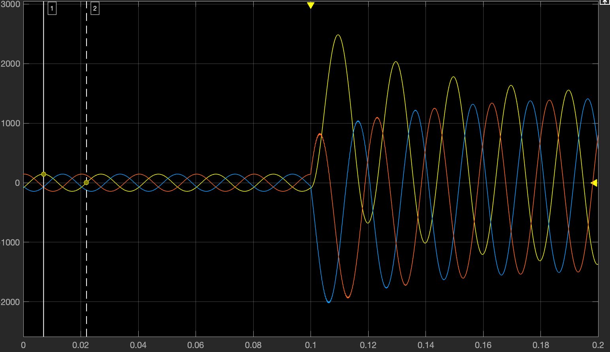

Fig. 15. The Current of A-B-C-ground

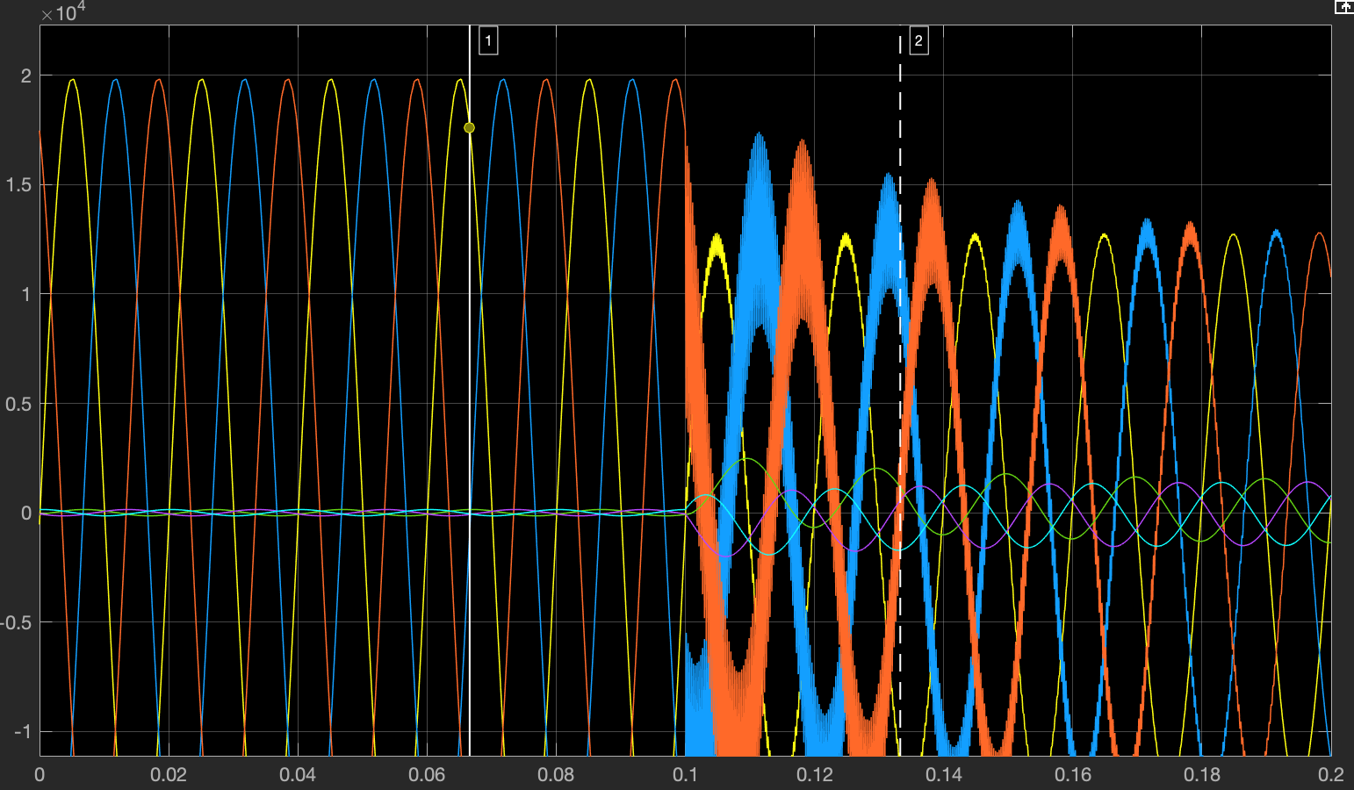

Fig. 16. The Voltage of A-B-C-ground Fault

As can be seen from the above picture, the voltage and current change at 0.01s. Similarly, we can take the value in the first period after 0.01s and calculate it according to Equation (13) to get the distance to the fault. Because of the value in the first period, the result is more accurate. So, let's take the A-ground fault as an example. We compare the results of the short-window and the long-window differential equation technique.

|  |  |  |  |
| --- | --- | --- | --- |
| Event Number | Actual fault location (km) | A-ground by DET (km) | Difference (km) |
| 1 | 30 | 29.953 | 0.057 |
| 2 | 50 | 50.098 | 0.098 |
| 3 | 100 | 100.112 | 0.112 |
| 4 | 200 | 200.28 | 0.28 |

Table. 1. The results of A-ground fault by short-window DET

|  |  |  |  |
| --- | --- | --- | --- |
| Event Number | Actual fault location (km) | A-ground by DET (km) | Difference (km) |
| 1 | 30 | 30.012 | 0.012 |
| 2 | 50 | 50.018 | 0.018 |
| 3 | 100 | 99.978 | 0.022 |
| 4 | 200 | 200.055 | 0.055 |

Table. 1. The results of A-ground fault by long-window DET

From the test results, there are some errors in the data obtained. In particular, when the fault position is farther away, the error of the obtained data will be greater. And the long-window is more accurate than the short window detection.

# V. Simulation Results for Traveling Wave fault location

The simulation is based on MATLAB /Simulink. We respectively simulate the single-terminal fault location and the two-terminal fault location. The parameters of the simulated system are given below.

Vp=35000 V, f=50Hz

R1=0.01273, R0=0.3864

L1=0.9337e-3, L0=4.1264e-3

C1=12.74e-9, C0=7.751e-9

Length=300km

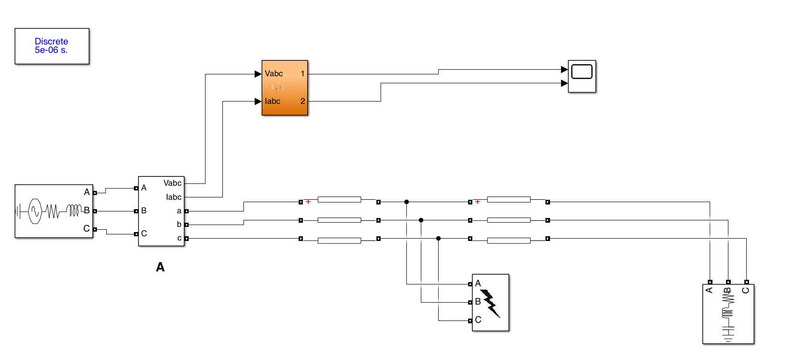

Fig. 17. The model of single-terminal fault location

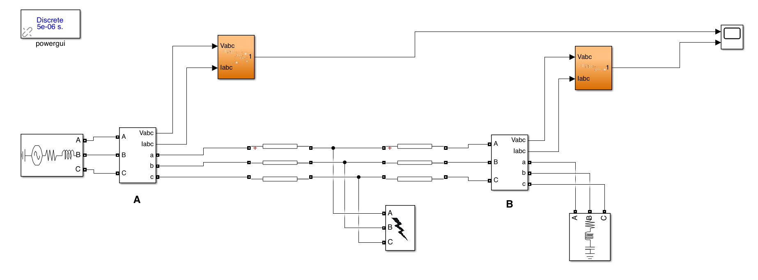

Fig. 18. The model of two-terminal fault location

We make a-g, a-b, a-b-c, a-b-c-g fault for simulation.

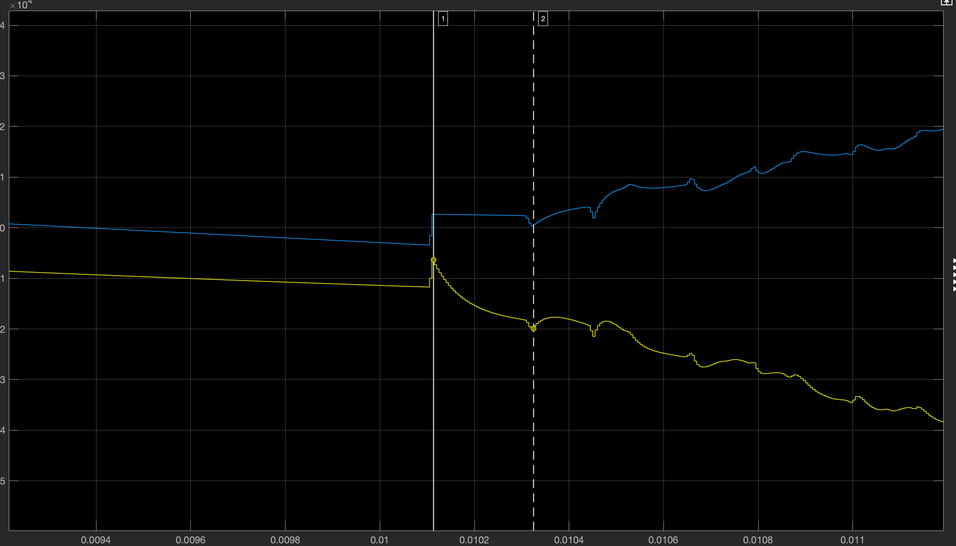

Fig. 19. The A-ground fault by single-terminal detection

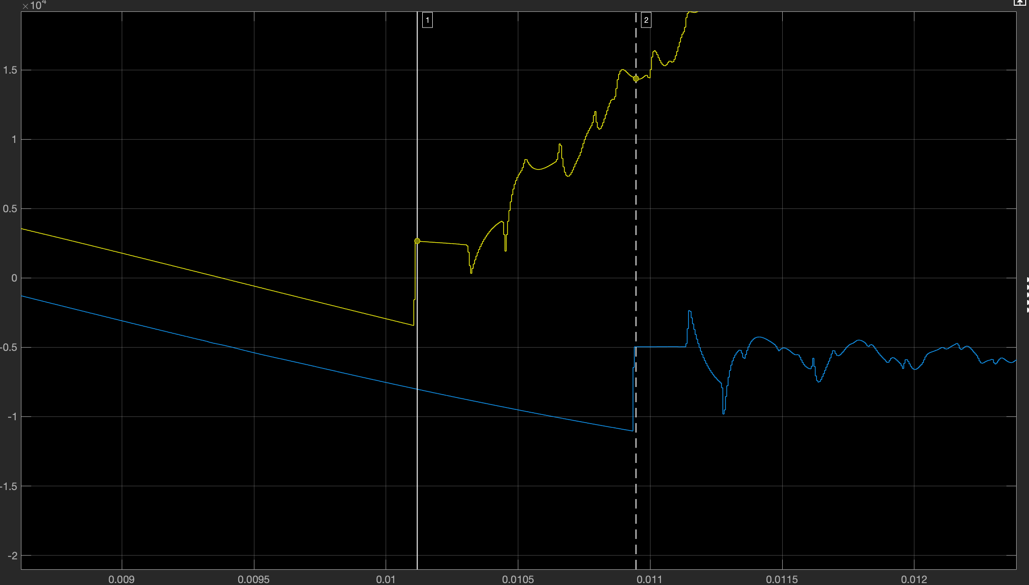

Fig. 20. The A-ground fault by two-terminal detection

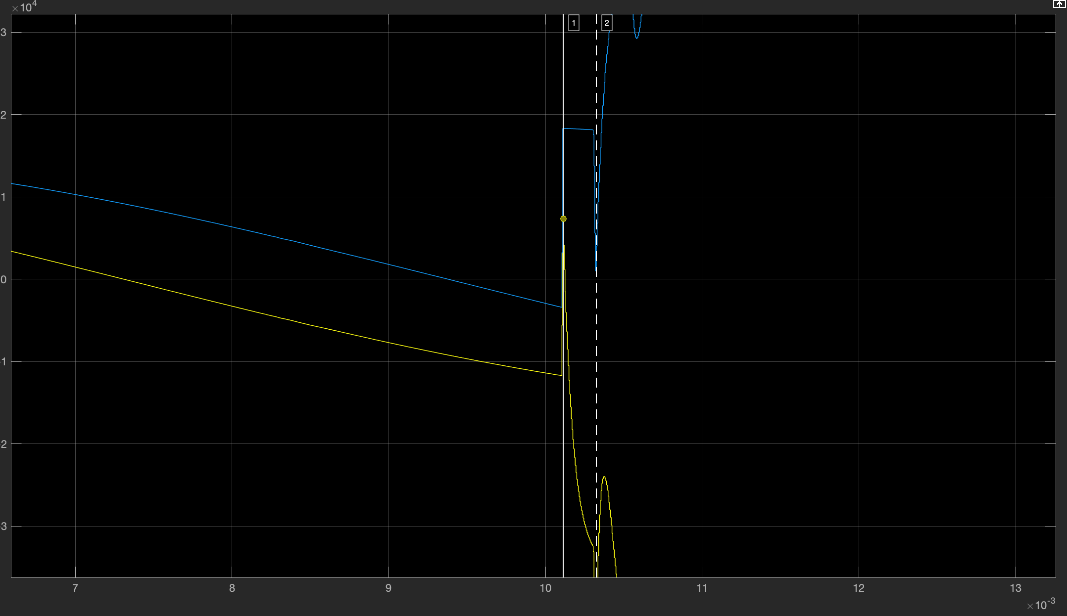

Fig. 21. The A-B fault by single-terminal detection

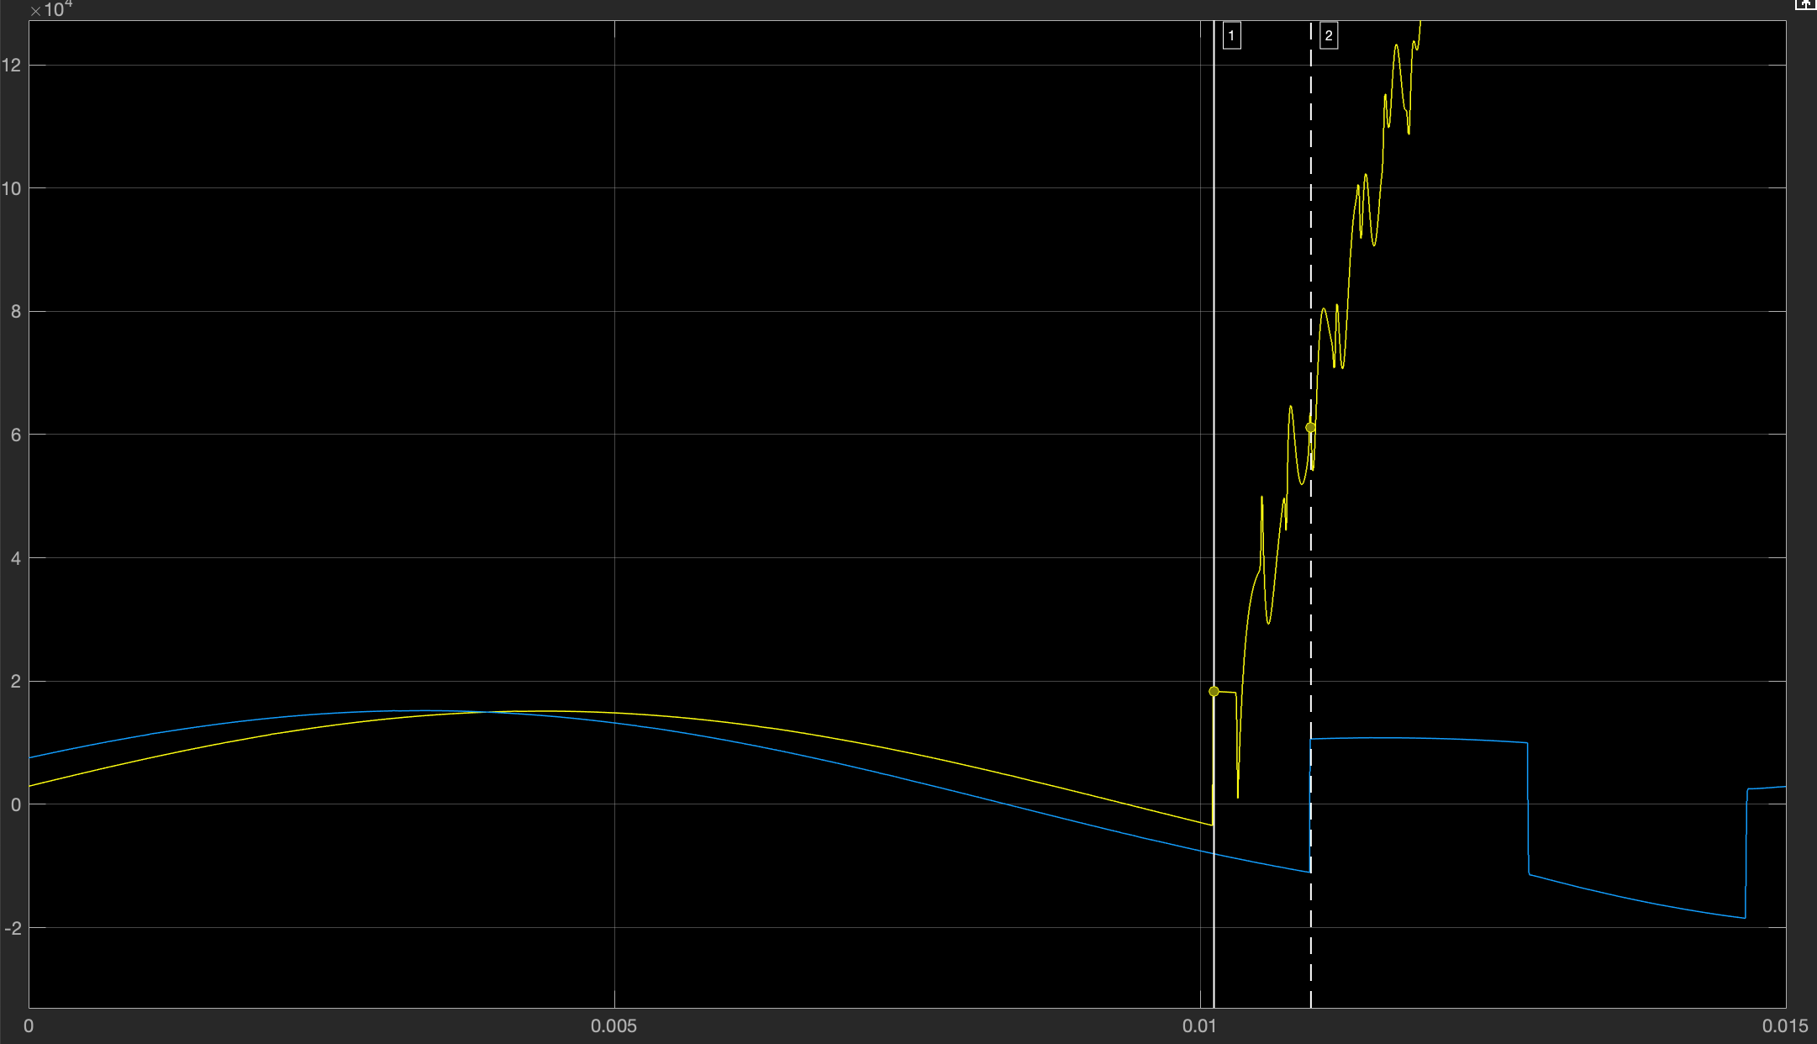

Fig. 22. A-B fault by two-terminal detection

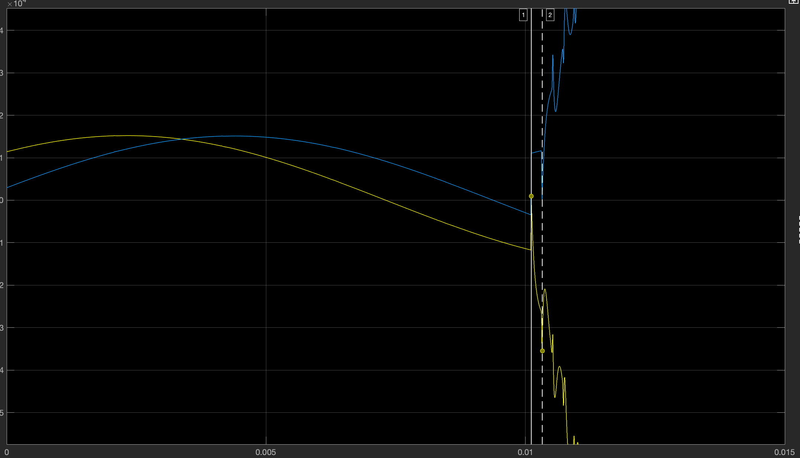

Fig. 23. A-B-C fault by single-terminal detection

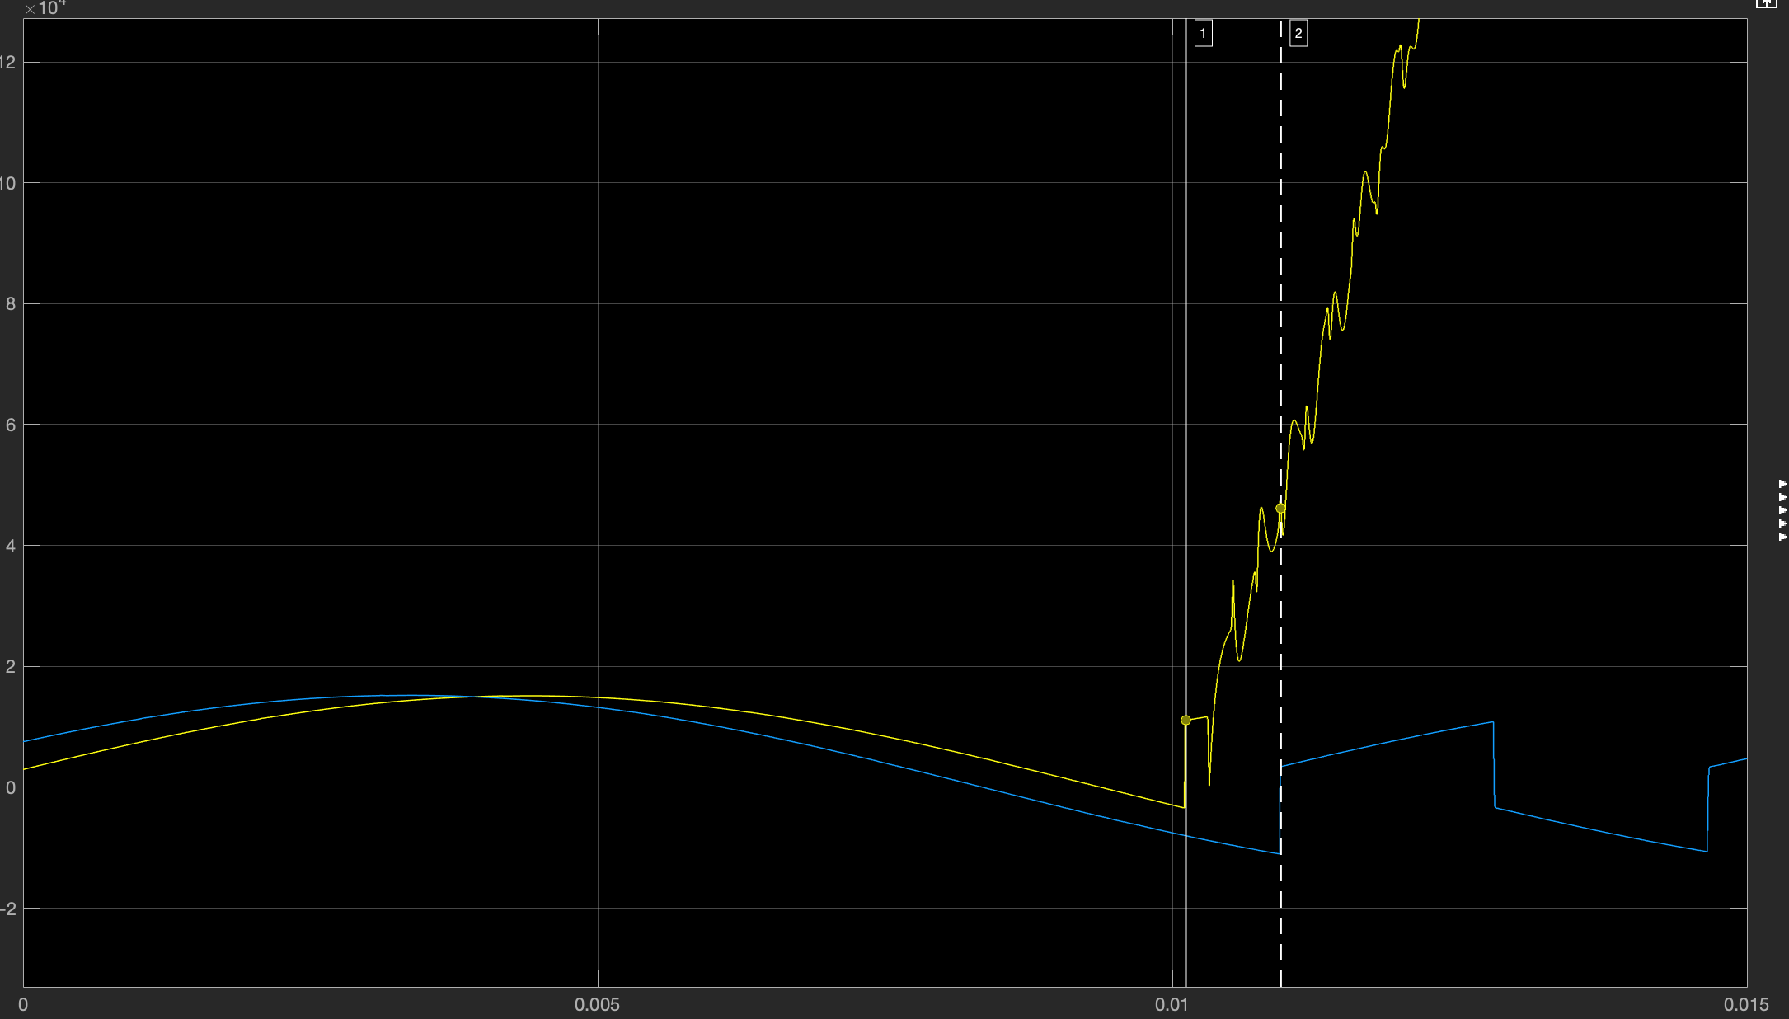

Fig. 24. A-B-C fault by two-terminal detection

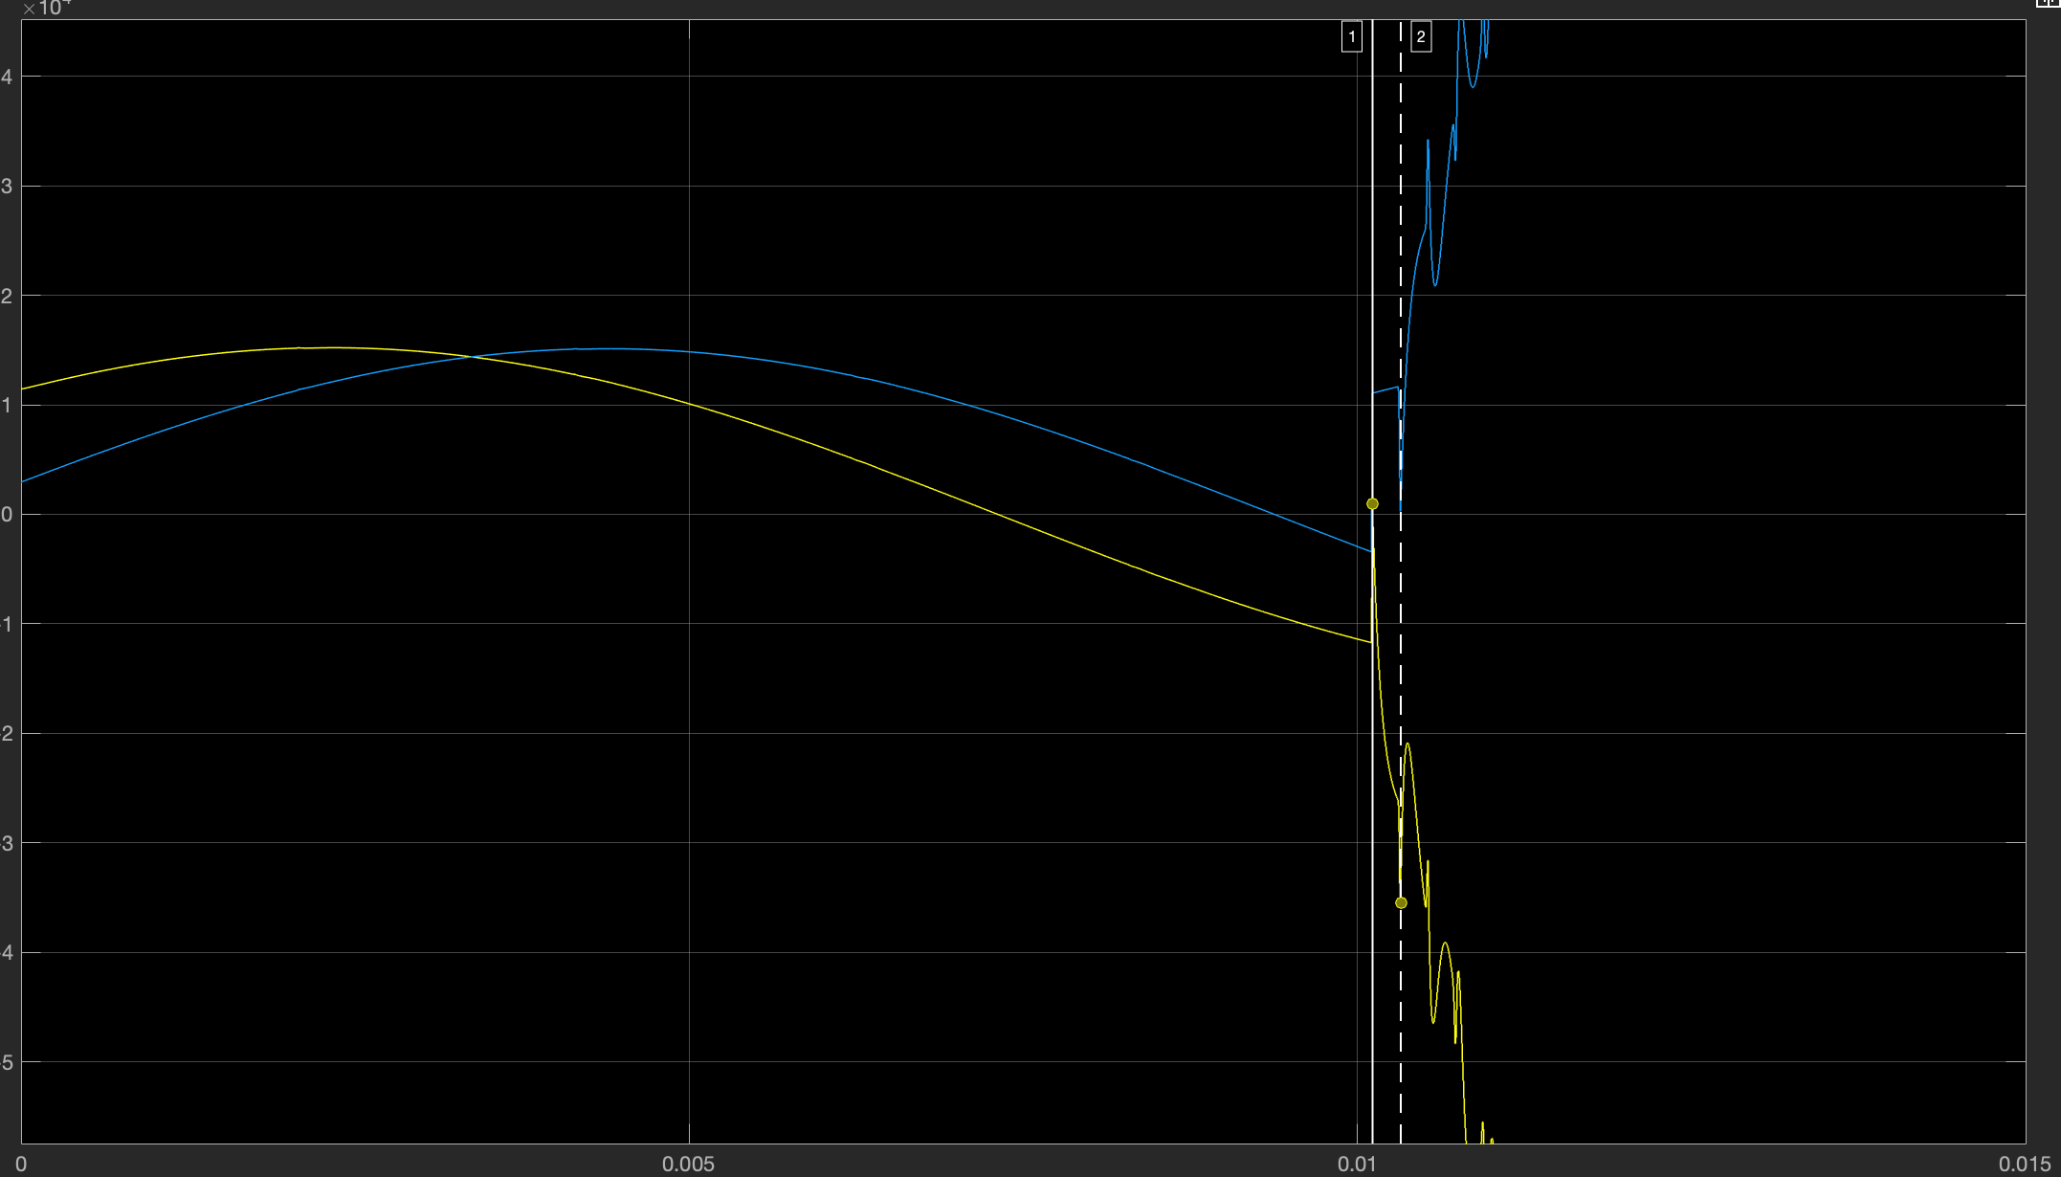

Fig. 25. A-B-C-ground fault by single-terminal detection

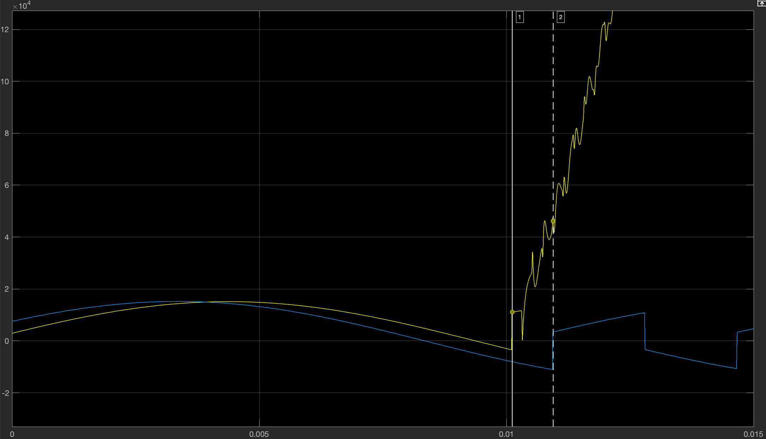

Fig. 26. A-B-C ground fault by two-terminal detection

After that, we calculate the result of the corresponding fault point for A-ground fault.

|  |  |  |  |
| --- | --- | --- | --- |
| Event Number | Actual fault location (km) | A-ground by single-terminal detection (km) | Difference (km) |
| 1 | 30 | 30.657 | 0.657 |
| 2 | 50 | 50.559 | 0.559 |
| 3 | 100 | 99.6449 | 0.3551 |
| 3 | 150 | 149.4653 | 0.5347 |
| 5 | 200 | 200.3548 | 0.3548 |

Table. 2. The results of A-ground fault by single-terminal detection

|  |  |  |  |
| --- | --- | --- | --- |
| Event Number | Actual fault location (km) | A-ground by two-terminal detection (km) | Difference (km) |
| 1 | 30 | 29.94 | 0.06 |
| 2 | 50 | 50.1633 | 0.1633 |
| 3 | 100 | 100.0761 | 0.0761 |
| 3 | 150 | 150 | 0 |
| 5 | 200 | 199.8959 | 0.1041 |

Table. 2. The results of A-ground fault by two-terminal detection

It can be found that the result of Two-Terminal Detection is obviously more accurate than that of Single-Terminal Detection. Especially if the fault point is 150km, which means the midpoint of the entire line. As you can see, the error measured by Two-Terminal Detection is 0. Finally, we compare the results of Differential equation technique with Traveling Wave protection.

|  |  |  |  |
| --- | --- | --- | --- |
| Actual fault location for  30 km | Differential Equation technique | Traveling Wave by single-terminal detection | Traveling Wave by two-terminal detection |
| The test result (km) | 28.99 | 30.657 | 29.94 |
| Error (km) | 1.01 | 0.657 | 0.06 |

Table. 3. The comparison of experimental results for the fault point of 30km

|  |  |  |  |
| --- | --- | --- | --- |
| Actual fault location for  50 km | Differential Equation technique | Traveling Wave by single-terminal detection | Traveling Wave by two-terminal detection |
| The test result (km) | 47.68 | 50.559 | 50.1633 |
| Error (km) | 2.32 | 0.559 | 0.1633 |

Table. 4. The comparison of experimental results for the fault point of 50km

|  |  |  |  |
| --- | --- | --- | --- |
| Actual fault location for  100 km | Differential Equation technique | Traveling Wave by single-terminal detection | Traveling Wave by two-terminal detection |
| The test result (km) | 96.33 | 99.6449 | 100.0761 |
| Error (km) | 3.67 | 0.3551 | 0.0761 |

Table. 5. The comparison of experimental results for the fault point of 100km

|  |  |  |  |
| --- | --- | --- | --- |
| Actual fault location for  200 km | Differential Equation technique | Traveling Wave by single-terminal detection | Traveling Wave by two-terminal detection |
| The test result (km) | 194.62 | 200.3548 | 199.8959 |
| Error (km) | 5.38 | 0.3548 | 0.1041 |

Table. 6. The comparison of experimental results for the fault point of 200km

According to the comparison of experimental results, we can find that the Traveling wave fault location is more accurate than the Differential Equation technique fault location. In fact, in this comparison of experimental data, Traveling wave fault location cannot be proved to be more accurate than the Differential Equation technique fault location. Because we only use six sets of data when we calculate the differential equation. If we enlarge the array of samples, we can get more precise results. But for Single-Terminal Detection and Two-Terminal Detection by Traveling Wave Fault Location, it is not difficult to find that the error of the calculation result of two-terminal detection is less than that of single-terminal detection.

# Conclusion

The differential equation technique is a digital protection technique used for distance protection and fault location. It is a discrete algorithm, easy to implement in digital circuits, better than the algorithm based on Fourier. The trapezoidal integral method (short window length algorithm) is generally used in traditional line parameter estimation and fault location. Because the algorithm is simple and easy to calculate, it has great benefits for future development.

In addition, this paper introduces traveling wave protection fault location. In the actual problem solving, there are Single-Terminal Detection and Two-Terminal Detection, Two-Terminal Detection is more accurate than Single-Terminal Detection. Traveling wave protection, a mainstream protection method in power system, has a wide range of applications.

# REFERENCES

1. M. Garcia-Gracia, W. Osal, and M.P. Comech, “Line protection based on the differential equation algorithm using mutual coupling”, Electric Power System Research, vol.77, pp. 566-573, April 2007.
2. J. Izykowski, R. Molag, E. Rosolowski and M. M. Saha, "Accurate Location of Faults on Power Transmission Lines With Use of Two-End Unsynchronized Measurements", IEEE Transactions on Power Delivery, vol. 21, no. 2, pp. 627-633, 2006.
3. Magnus Akke, James T. Thorp, “Some improvements in three-phase differential equation algorithm for fast transmission line protection”, IEEE Transactions on Power Delivery, vol. 13, no.1, pp. 66-72, January 1998.
4. H. Yeh, S. Sim, R. Yinger and R. Bravo, "A comparative study of orthogonal algorithms for detecting the hif in mdcs", 2017 IEEE Green Energy and Smart Systems Conference (IGESSC), pp. 1-7, Nov 2017.
5. Yeh, D. Tran and R. Yinger, "High impedance fault detection using orthogonal transforms", 2014 IEEE Green Energy and Systems Conference (IGESC), pp. 67-72, Nov 2014.
6. WANG Jun, DONG Xinzhou and SHI Shenxing, "Traveling wave transmission research for overhead lines of radial distribution power systems considering frequency characteristics", Proceedings of the CSEE, vol. 33, pp. 96-102, 2013.
7. LIANG Rui and SUN Shixiang, "A combined method for single-ended traveling wave fault location", Power System Technology, vol. 37, pp. 699-706, 2013.
8. A.T. Johns and S.K. Salman, “Digital Protection For Power Systems”, Peter Peregrinus Ltd. on behalf of The institution of Electrical Engineers, pp.103-150, 1997.
9. D.Yildiz, S. Karagol and O. Ozgonenel, “Estimation of online transmission line parameters and fault location by using different differential equation algorithms”, IEEE Electrical and Electronics Engineering Department, p.2, Nov 2015.
10. D. Glover, Mulukutla S. Sarma and Thomas Overbye, “Power Systems Analysis and Design”, CL-Engineering 5th edition, 2010.
11. Edmund O. Schweitzer, III, Armando Guzmán, Mangapathirao V. Mynam, Veselin Skendzic, and Bogdan Kasztenny, “Locating Faults by the Traveling Waves They Launch”, Schweitzer Engineering Laboratories, Inc, 2014.
12. Armando.Guzmán, Veselin.Skendzic, and Mangapathirao V. Mynam, “Traveling Wave Fault Location in ProtectiveRelays: Design, Testing, and Results”, Schweitzer Engineering Laboratories, Inc, May 2013.